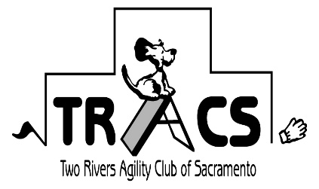
WELCOME
General Information Letter

Thank you for entering TRACS AKC Agility Course Tests 1 & 2 and/or Charity Fun Runs being help Saturday July 9th at Heath Bar Ranch (4861 Artesia Rd).

Directions:
From Sacramento Area: Take I-50 North towards South Lake Tahoe.
Take Exit 39 = Shingle Springs Dr. Turn Left.

From Placerville Area: Take I-50 South towards Sacramento.
Take Exit 39 = Shingle Springs Dr. Turn Right.

Stop at main gate and enter the following code into keypad: #9663 (make sure # is entered first)
Travel approximately 1 mile and turn Right onto Artesia Rd.
Travel approximately 1/2 mile. Show site will be on your left.
Look for signs indicating parking area. No parking is allowed on the main road next to arena.
Show site is located in a gated community to please drive slow.

ACT: Check-in 8:30 a.m. –
ACT 1 Round 1 walk thru (4/8/12) at 9:00
walk thru (16/20/24) at 9:15
Run (4/8/12/16/20/24) at 9:30
ACT 1 Round 2 same order after build
BUILD ACT 2 COURSES
ACT 2 Round 1 walk thru (16/20/24)
walk thru (4/8/12)
Run (16/20/24/4/8/12)
ACT 2 Round 2 same order after build

After ACT is completed, check out the great tracking demo – another great venue that you and your dog to enjoy

Charity Runs: Check-in 1:30 p.m. – Walk Thru all heights start at 2:00 p.m.
First Dog at 2:30
Run round 1 of each height then each
subsequent rounds through each height

The non-profit chosen is the El Dorado County 4H Dog Agility Project

If you have any questions – contact Sandra Zajkowski tobigal@yahoo.com or (916) 501-8319

See you there

